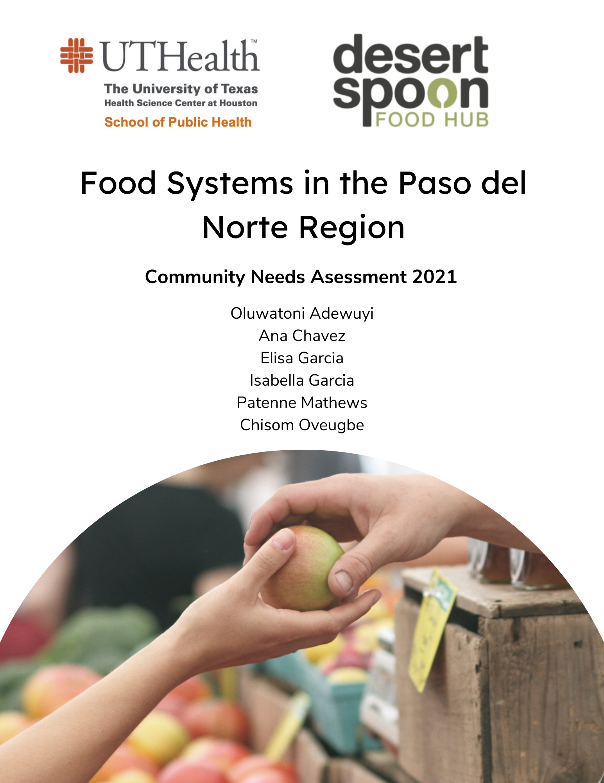

**Table of Contents**

| Introduction…………………………………………………………………………………. | 3 |
| --- | --- |
| Project Goal……………………………………………………………………………….... | 6 |
| Target Audience…………………………………………………………………………….. | 6 |
| Methods…………………………………………………………………………………….. | 9 |
| GIS Mapping……………………………………………………………………………….. | 11 |
| Results…………………………………………………………………………………….... | 17 |
| Recommendations………………………………………………………………………….. | 27 |
| References………………………………………………………………………………….. | 30 |
| Appendix…………………………………………………………………………………… | 32 |

**Introduction**

Community needs assessments (CNA) are systematic evaluations of a community’s assets and resources that can be utilized in future community planning and decision-making processes. Through the process of creating a community needs assessment, multiple stakeholders invested in the success of a community work together and share ownership over data collection and analysis. CNAs are the first step in maximizing and improving the resources and processes available to a community by identifying areas of need. After completing a CNA, communities and other invested stakeholders can work together to prioritize action items recommended by the CNA, create interventions that make a change in the community, and evaluate the progress made by all key coalition members. CNAs are rooted in community involvement -- members of the target population should help guide and execute the CNA so that it is most representative of their specific assets and needs.

This CNA delves into the food system of the Paso del Norte region, represented by the counties of El Paso, Hudspeth, Doña Ana, Otero, and Luna in the southwestern United States. It has been formed through a collaboration between Desert Spoon Food Hub, a food hub serving the Paso del Norte region, and students at the University of Texas Health Science Center School of Public Health. Through the process of creating a CNA, all coalition members have worked together to define a food system, understand the health consequences of both sustainable and unsustainable food systems, investigate secondary data sources to recognize specifics about the Paso del Norte region, develop a survey to gain community input on the food system in the area, analyze these primary and secondary data sources, and finally give recommendations to the region based on these findings.

**Food Systems**

According to the Food and Agriculture Organization of the United Nations (FAO), food systems consist of all partners with a hand in the production, gathering, processing, distribution, consumption, and disposal of food derived from farming, forestry, and fishing (FAO, 2018). Additionally, the economic, social, and natural environments that the food system resides in can be considered part of the greater food system. Multiple subsystems keep a food system moving, including farming and waste management. Food systems interact with other macro-level systems that help a community operate, including healthcare and transportation systems. The American Public Health Association (APHA) states that a sustainable food system provides nutritious foods while maintaining a healthy environment, encourages local production and distribution, makes healthy foods accessible to all, and is humane and just to all participants, from the farmers to the consumers (Story et al., 2009).

**Health Consequences Related to Diet**

Access to healthy foods to supplement a complete diet is paramount to ensuring a community’s long-term health. The United States Department of Agriculture (USDA) recently published the 2020-2025 Dietary Guidelines for Americans (DGA) to encourage citizens to “make every bite count” (USDA, 2020). These guidelines truly take a lifespan approach to nutrition by emphasizing the specific actions that different age groups can take to optimize their diets. The four guidelines provided by the USDA are: follow a healthy diet pattern at every age; customize and enjoy nutrient-dense food and beverage choices to reflect personal preferences, cultural traditions, and budgetary considerations; focus on meeting food group needs with nutrient-dense foods and beverages and stay within calorie limits; and limit foods and beverages higher in added sugars, saturated fat, and sodium and limit alcoholic beverages (USDA, 2020). They define “nutrient-dense” foods and beverages as those that provide individuals with vitamins and minerals while also being low in added sugar, saturated fat, and sodium. The food system of the Paso del Norte region should aim to provide its constituents with nutrient-dense food and beverages that would allow them to follow each one of the guidelines set forth by USDA.

In considering food systems, and specifically the food system of the Paso del Norte region, the consequences of diet must be examined. The Centers for Disease Control and Prevention (CDC) lists four risk factors for preventable chronic disease, one of which is poor nutrition (CDC, 2021). Like the USDA, the CDC takes a lifespan approach to diet and nutrition to encourage Americans to pursue a healthy lifestyle. They recognize that most Americans do not adhere to a healthy diet, as outlined by the USDA, and explain many diet-related diseases and disorders that can be prevented with a nutrient-dense diet. Poor nutrition has been shown to increase the risk of developing obesity, heart disease, type 2 diabetes, cancer, and brain function deficits in newborns and increase the risk of suffering from a stroke (CDC, 2021). These diseases and disorders impact the Paso del Norte region in a pervasive manner. In 2017, the percentage of adults who have obesity in the area (defined as having a Body Mass Index greater than or equal to 30) was 30.6%, compared to the national average of 42.4% (CDC, 2021; Healthy Paso del Norte, 2017). The percentage of adults who have been informed that they have coronary heart disease in the Paso del Norte region is higher than the national average, with 8.1% of Paso del Norte adults being diagnosed compared to 4.1% of American adults being diagnosed (CDC, 2021; Healthy Paso del Norte, 2017). High blood pressure and high cholesterol are two major determinants of future coronary heart disease. The prevalence of both conditions is higher in the Paso del Norte region in contrast with the national average (CDC, 2021; Healthy Paso del Norte, 2017). The prevalence of type 2 diabetes in the area is 12.1%, compared to the national average of 9.3% (CDC, 2021; Healthy Paso del Norte, 2017). These statistics indicate that diet-related diseases and disorders are highly prevalent and highly impactful on the Paso del Norte region. Working towards improving the health of the region starts with improving the food system.

**Project Goal**

This community health needs assessment aims to improve the current state of the Paso Del Norte region foods system through stakeholder input on how to identify strengths and areas of improvement. The goal is in line with our mission of getting communities more access to healthier foods, which will alleviate some of the health issues described above. The first objective for this assessment is to establish a relationship with members of the food system by having our community partner, Adriana Clowe, bridge the gap with us for communication. With the help of the community partner, we were able to contact the people of interest. This is very important because we need that relationship to know what has and has not worked for the members in the past and what they are struggling with now. The second objective is to finalize a survey with the help of Adriana and have her email the food partners the survey to fill out and return. Without a survey, there is no way of knowing the needs of a community, and without the correct questions being asked, there is no way of knowing what needs to be addressed. The third objective is to highlight the areas that need improvement by examining data and survey results. To fulfill this objective, we not only had surveys but also made maps that showed indicator data for each county.

**Target Population**

The overall target population for this needs assessment are all members of the food system in the Paso del Norte Region: producers (farmers), partners (restaurants and food hubs), consumers, and communities. Because of time constraints, we narrowed it down to producers and partners alone, prioritizing producers in the process.

Paso Del Norte translated Pass of the North, was given its name by Spanish explorers that arrived in the 1500s and became an essential stop for people traveling along the Camino Real. The Camino Real was the principal corridor for trade between the Pueblo Indians, the Spanish and Mexican merchants. The Paso del Norte region is located at the virtual midpoint of the 1,500-mile border shared by the United States and Mexico. The bi-national metropolitan area is located 1,700 miles southwest of Washington, DC, and 970 miles northwest of Mexico City. (Regional Stakeholder Committee). The region includes counties in New Mexico and Texas. These counties include El Paso TX, Hudspeth TX, Doña Ana NM, Luna NM, and Otero, NM.

**El Paso**

El Paso has the highest population, 839,238 people, and its population seemed to be in an uptrend from 835000 in 2014. In its age distribution, 7.3% of the population is under 5, 26.7% under 18, 12.5% over 65. The gender distribution is 50.6% female and 49.4%, male. The population is predominantly white 91.8%, 4.0% African American, 1.1% American Indian/Native Alaskan, Asian 1.4%, 0.2% Native Hawaiian/Other Pacific Islander, 1.5% of two or more races, 82.9% Hispanic or Latino, 11.6% non-Hispanic white. The median household income for persons Living in El Paso is $46871, with 20.2 %of its population living below poverty, which saw a decrease from 21.3% in 2018 (Healthy Paso del Norte). 656 farms are occupying 142675 total acres (217 acres average size per farm) 552 of the 656 farms are used for cropland (39915 acres) (USDA)

**Hudspeth**

Hudspeth has the lowest population at 4886 people. 5.4% of the population under 5, 20.8% under 18 and 15.9% over 65. The gender distribution is 46.9% male and 53.1% female. The population is predominantly white at 90.2%. 3.8% African American, 2.0% American Indian/Alaska Native, 1.6% Asian, 0.2% Native Hawaiian/Other Pacific Islander, 2.3% two or more races, 76.9% Hispanic, and 17.2% non-Hispanic white. The median household income is on an uptrend from $29,318 in 2018 to $31,677. The percent living below poverty shows a downward trend from 28.2% in 2018 to 24.4% in 2019. In this region, 134 farms occupy 2,276,024 acres total (16,985 acres is the average size of a farm). 46 of the 134 are cropland farms (20473 acres).

**Doña Ana**

Doña Ana has a total population of 218,195. 5.4% of the population under 5, 24.3% under 18, 16.2% over 65. The gender distribution is 50.9% female and 49.1%, male. The population is predominantly white at 91.8%. 2.4% African American, 2.3% American Indian/Alaskan Native. 1.3% Asian, 0.2% Native Hawaiian, 1.9% mixed race (two or more races), 68.8% Hispanic/Latino, 26.7% White non-Hispanic. The median household income is on an uptrend from $39,164 in 2018 to $40,973 in 2019. The percent living below poverty shows an upward trend from 27.7% in 2018 to 26.4% in 2019. In this county, 1946 farms occupy 528,270 total acres; the average size of a farm is 271 acres. Out of the 1946 farms, 1776 farms are used for cropland (93126 acres).

**Luna**

Luna has a total population of 23709 people. 7.5% of the population under 5, 26% under 18, 21.2% over 65. The gender distribution is 49.5% female and 50.5%, male. The population is predominantly white at 92.6%. 1.9% African American, 2.5% American Indian/Alaska Native, 1.1% Asian, 0.2% Native Hawaiian/Other Pacific Islander, 1.8% Mixed race (two or more races), 67.9% Hispanic, 28.5% white non-Hispanic. The median household income is on a downtrend from last measured to $29,360 in 2019. The percent living below poverty shows a downward trend from 30.2% in 2018 to 27.7% in 2019. In this county, 211 total farms occupy 575,844 total acres; the average size of a farm is 2729 acres. 134 Farms are used for cropland (30007 total acres)

**Otero**

Otero has a total population of 67490 people. 6.7% of the population under 5, 17.3% over 65, 22.9% under 18. Its gender distribution is 48.2% female and 51.8%, male. The population is 82.7% white, 4.2% African American, 8.3% American Indian/Alaska Native, 1.6% Asian, 0.3% Native Hawaiian/other Pacific Islander, 3.1% mixed race (two or more races), 38.6% Hispanic, 48.3% White non-Hispanic. The median household income is $41,988, showing an uptrend in recent years. 22.1% of the population in Otero county lives below the poverty level, and that number is predicted to continue rising. The county contains 473 total farms occupying 1019246 acres of land, the average size of a farm is 2155 acres. 259 farms out of the 473 total are used for cropland. 8639 total cropland acres.

**Methods**

To ensure complete comprehension of food systems in the Paso del Norte Region and diet and nutrition for the individuals living under this system, many diverse data was sought out. Primary data collection was geared towards Partners and Producers of the region in survey questions via Qualtrics. These surveys included multiple choice and short answer questions concerning budgeting, production, barriers preventing expansion and/or increased production, and distribution strategies. The answers to this particular survey increased insight into the significant Partners and Producers for the region.

Secondary data collection focused on local food systems, infrastructure, and demographic data of the region. Data on cropland size, county summary, farmers market density, number of farms in the region, overall food environment, and harvested farmland were all collected for each of the five counties encompassing the Paso del Norte Region. This data brought awareness to the sources and their abundance, or lack of, food. Analysis of data on cropland size and number of farms in the region, for example, can help one depict the amount of food available to those in the region.

Lastly, demographic data were collected from the United States Census Bureau to better understand the quality of life and nutrition for the individuals living in the region. This data includes but is not limited to ethnic and racial makeup, age makeup, population characteristics, employment status, and education. This information was coupled with regional food assessments completed on the five counties. Regional food assessments include data on poverty, children living below poverty level, families living below poverty level, and median household income. With the summation of data collected, we were able to identify issues within the current food system and develop informed outcomes of interests, along with a proposed budget.

**GIS Mapping**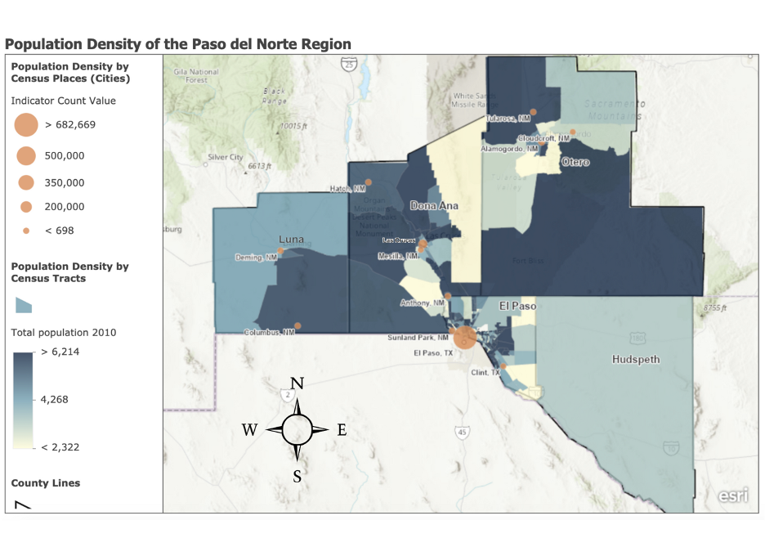

This map depicts the population density of the Paso del Norte region at two different levels: census tract and census place. The United States Census Bureau uses these two parameters to describe population data, with census tracts representing geographic parameters and census places representing cities. The census tract data were drawn from the Centers for Disease Control and Prevention (CDC) PLACES Project, which aims to provide information on 27 chronic disease measures across the United States at the county, place, census tract, and zip code levels. Population data was gathered as a part of this project, and the density of the population in each census tract can be visualized by the blue gradients on each of the five counties of the region. The census place data was drawn from the U.S. Census published by the Paso del Norte Health Foundation. Twelve major cities of the region are visualized on the map by the orange dots, and the different areas of these dots represent the population density in each city.

When assessing the food system of the Paso del Norte region, it is essential to understand the overall population density and spread in each of the five counties. Resources within the food system must be allocated appropriately to ensure that individuals in the region have access to locally grown produce, producers know how much food to grow, and partners can aptly participate in the food system.

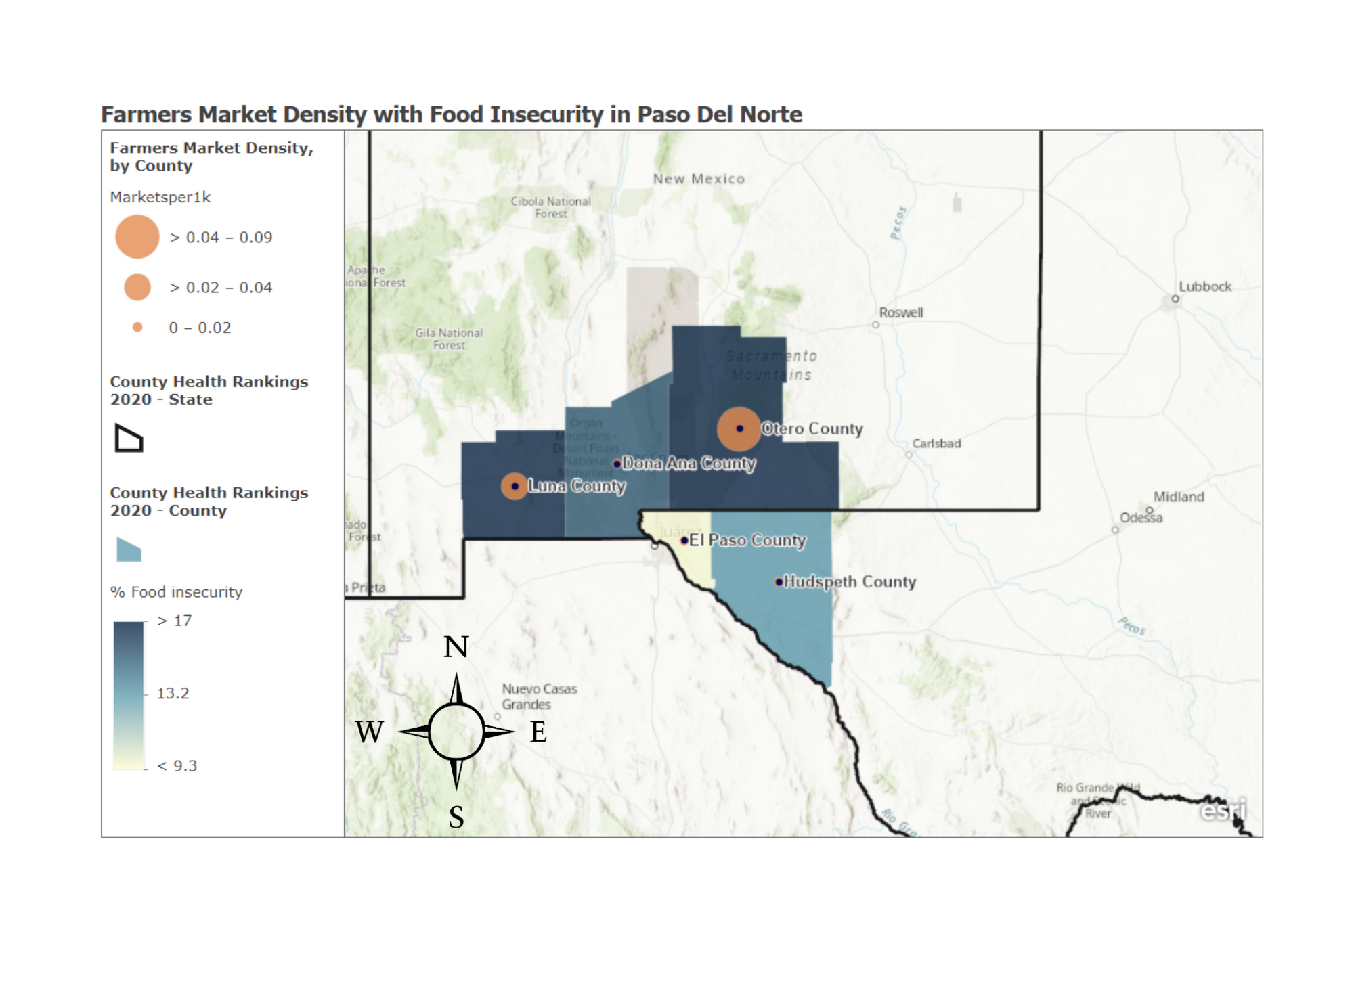

This map shows the density of farmers’ markets in counties within the Paso del Norte region measured as the number of calls per 1000. The data indicate that Otero county has the highest density of markets, having a range between 0.04-0.09 markets per 1000, followed by Luna county in the mid-range 0.02-0.04 markets per 1000, Hudspeth, El Paso, and Doña Ana all have similar densities between 0-0.02 markets per 1000. The map also depicts the % food insecurity. It shows that Luna and Otero’s counties have up to 17% food insecurity which is the highest in the Paso del Norte region despite having the higher density of farmers’ market. El Paso county boasts the lowest food insecurity among counties in the region at 9.3% or below.

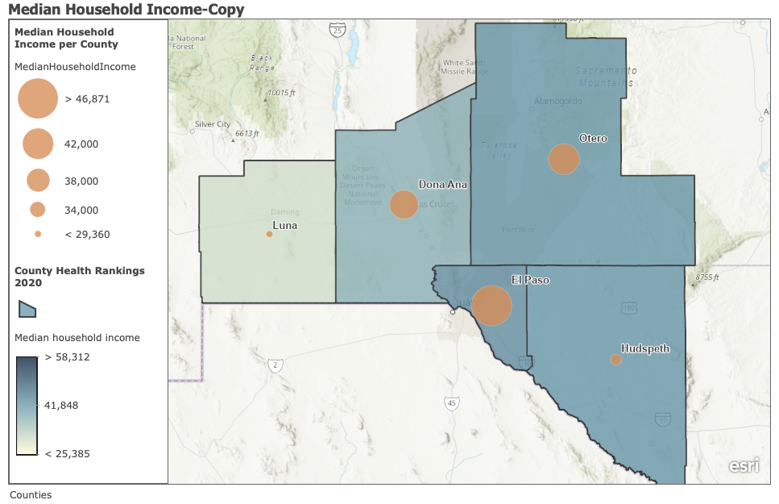

This map shows the median household income for the Paso del Norte Region. The lowest value is $29,360, and the highest value is $46,871. Half of the values are between $29,360 and $40,973. The middle (median) value is $40,973. El Paso has the highest median household income at $46,871, next is Otero at $41,988, then Doña Ana at $40,973, next Hudspeth at $31,677, and lowest is Luna at $29,360. The big orange to small orange dots represents the median household income by size. The biggest dot for El Paso is the highest, and the smallest dot for Luna is the lowest median household income.

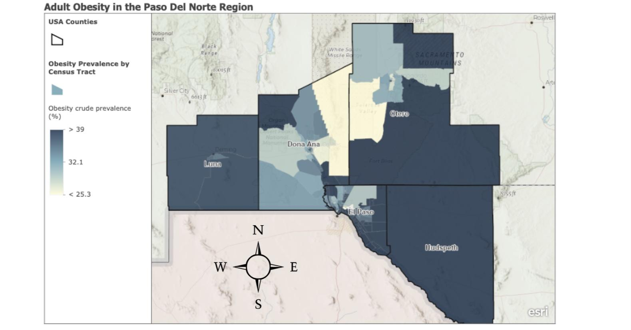The GIS map above depicts Adult Obesity in the Paso del Norte region. The map shows the obesity prevalence of adults by county. Among the five counties, Luna, Hudspeth, Doña Ana, El Paso, and Otero, Hudspeth, and Luna show the most significant prevalence of obesity with over 39% of crude prevalence. El Paso, Doña Ana, and Otero have at least half their population of Adults obese with >39% crude prevalence, while the remainder of the population maintains <25.3% prevalence of obesity or less. This data is relevant to the overall project as it reflects nutrition and quality of food availability in our target region. This information, coupled with the information from the other maps, access to grocery stores, food insecurity, household income, etc., will help us gain a better understanding of our population and their food sources which will aid in making informed recommendations to the food system(s).

The orange circles represent the Low Income and Low Access (LILA) to a grocery store indicator, as a percentage, for the counties in the Paso del Norte region in 2018. This data is from the Paso del Norte Health Foundation. The shading of the counties shows the limited access to healthy foods also as a percentage. This data was obtained from the ArcGIS program. Hudspeth county had the highest rate of LILA, 67.3%, and limited access to healthy foods. El Paso County had the smallest LILA percentage, 9.6%. 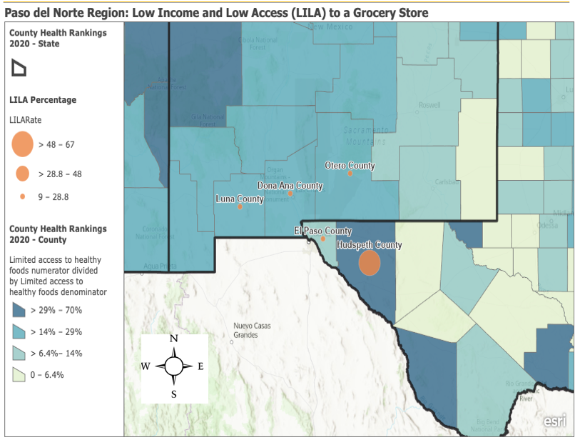

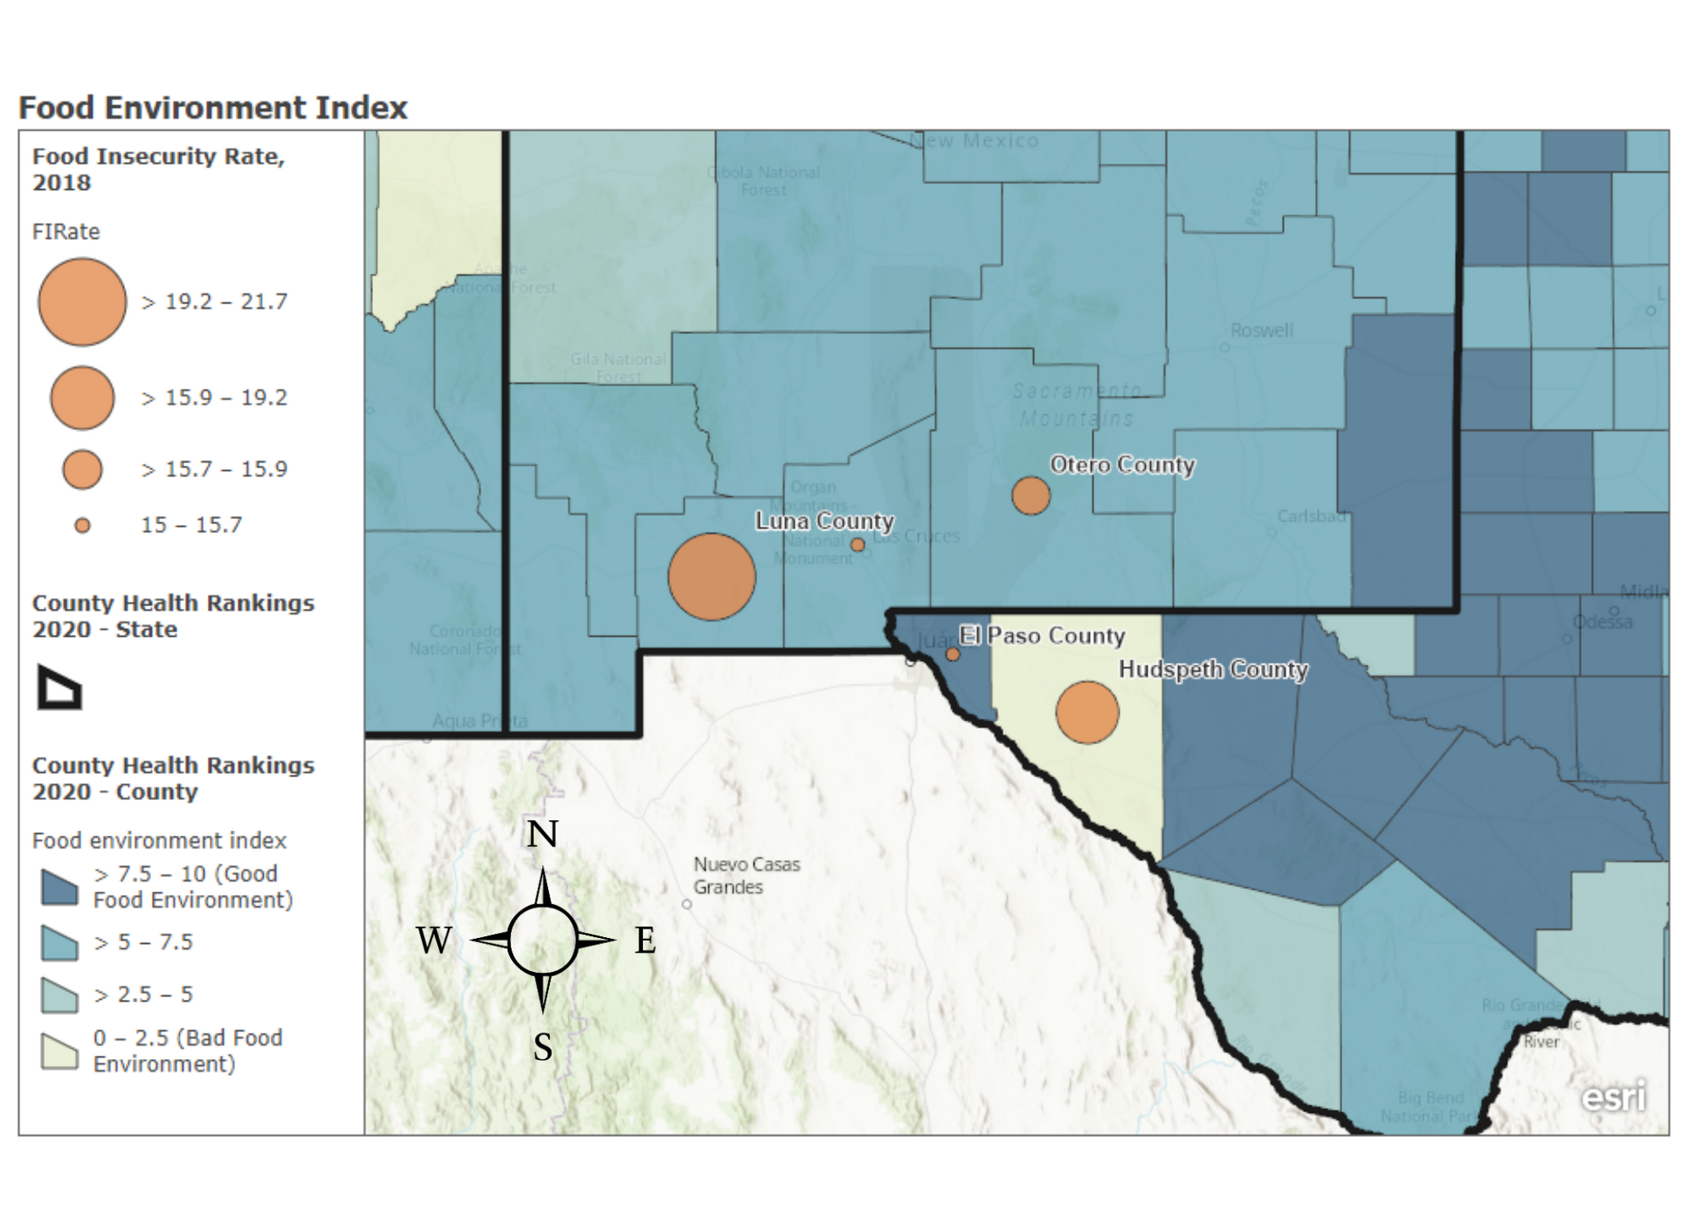**Food Environment Index and Food Insecurity in Paso del Norte Region**

This map identified the Food Environment Index and Food Insecurity Rates in Luna, Doña Ana, Otero, Hudspeth, and El Paso County. The counties that show a poor food environment indicate a high level of food insecurity, resulting in a possible relationship between lack of access to nutritious food and food insecurity in the Paso del Norte Region. One example is Hudspeth County, with a low Food Environment Index of 0-2.5 and a Food Insecurity rate of >15.9-19.2. We can also see the opposite visuals with El Paso County, where the Food Environment Index is high, and the Food Insecurity Rate is low.

**Results**

**Primary Data Findings**

The Director of Desert Spoon Food Hub and UTHealth SPH students worked together to develop two targeted surveys using Qualtrics. This survey was shared among partners and producers to obtain an accurate picture of the local food system landscape. Surveys were tailored for producers and partners; however, only data from producers was received due to no responses from the partners. The total sample of this assessment was 11 responses from producers in Paso del Norte Region. The following results are based on findings from surveys to producers.

***Land and Production***

Farmers who responded to the survey are located in La Cruces, El Paso, Arrey, Lamesa, San Miguel, and Monticello.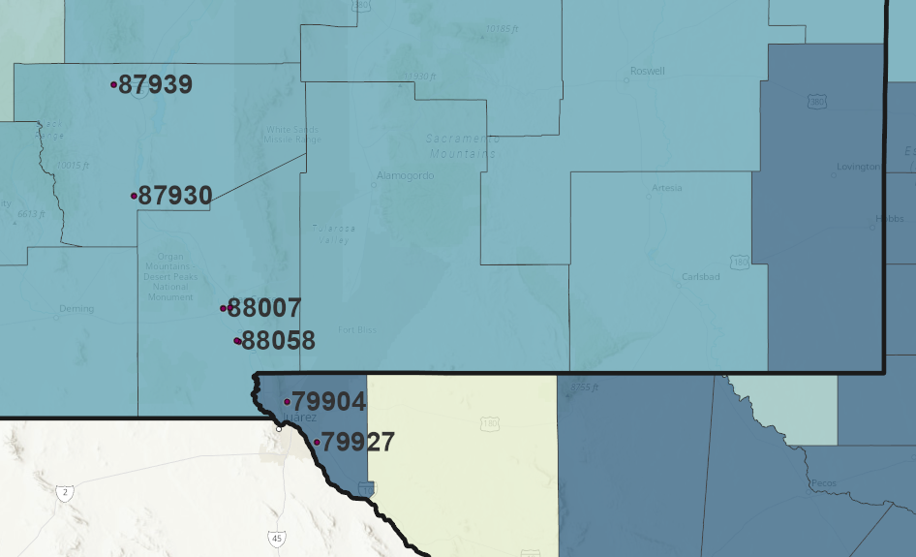

*ZIP Codes where farmers have located their farms.*

Survey results show that all the producers grow vegetables at their farms, and they showed an interest in increasing their fruit and vegetable production; however, most of the producers in the surveys farm less than 4 acres of land for fruits and vegetables, and they acknowledge the need for more land space.

| **Product** | **Producers Count** |
| --- | --- |
| Vegetables | 10 |
| Protein/Meat | 1 |
| Fruit | 7 |
| Grains | 0 |
| Eggs | 7 |
| Flowers | 3 |
| Legumes | 2 |
| Value-added product | 3 |
| Prepared food | 1 |
| Dairy | 1 |
| Processed fruits and vegetables (Frozen, chopped, etc.) | 1 |

*In this table, we can see that from the 11 farmers that responded to the survey, 10 produce vegetables and 7 produce fruit; only a few grow legumes, none produce grains, and one of the producers (canfarms) have processed fruits and vegetables.*

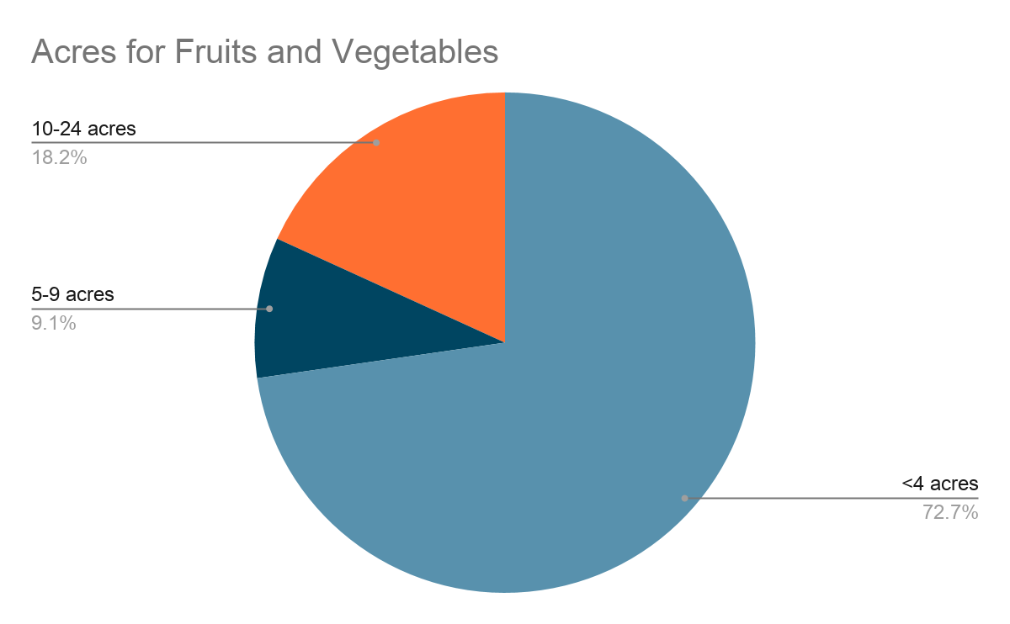

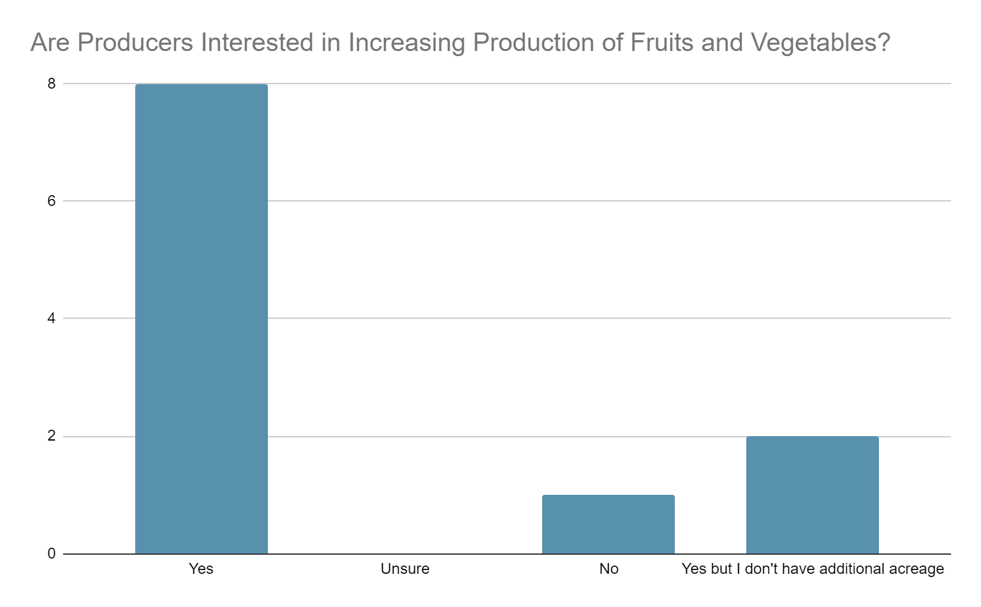

*Produces want to increase fruit and vegetable production; however, they do not have additional acreage. Most of the farmers grow fruits and vegetables in less than 4 acres of land and the majority responded that less than four additional acres would be enough for them to increase their production.*

***Barriers Preventing Farmers from Expanding their Business***

Farmers mentioned different barriers that would prevent them from expanding their business, one of the most obvious ones was lack of capital to purchase supplies and equipment; access to water, as well as lack of labor and/or skilled labor, was a repeated answer between the farmers.

Producers mentioned that they would like to expand their sales by having Community Supported Agriculture/CSA or Pre-sold Boxes and increasing participation at the farmers market. There is also an interest in wholesale; however, the three main reasons why farmers are not doing it are:

1. Volume- unable to provide enough product to fill the orders.
2. Pricing- Profits too low.
3. Certifications- most farmers don’t have the proper credentials that are needed.

We also found that most farmers manage their farms with limited equipment and available resources to profit, such as using personal vehicles, having the buyers pick up the product, or selling only at the farm.

Another critical area mentioned by the farmers and that it’s essential to consider is community education. When farmers were asked about barriers to selling locally grown produce and barriers preventing expanding their production to increase sales, they responded to a lack of knowledge from the community and low perception of value for locally grown produce. One concern from one of the producers was that customers expect lower prices with local produce but are willing to pay the full fee at specialty shops. Educating the community about the value of local produce could motivate the farmers to look for options to increase their production and sales due to higher demand.

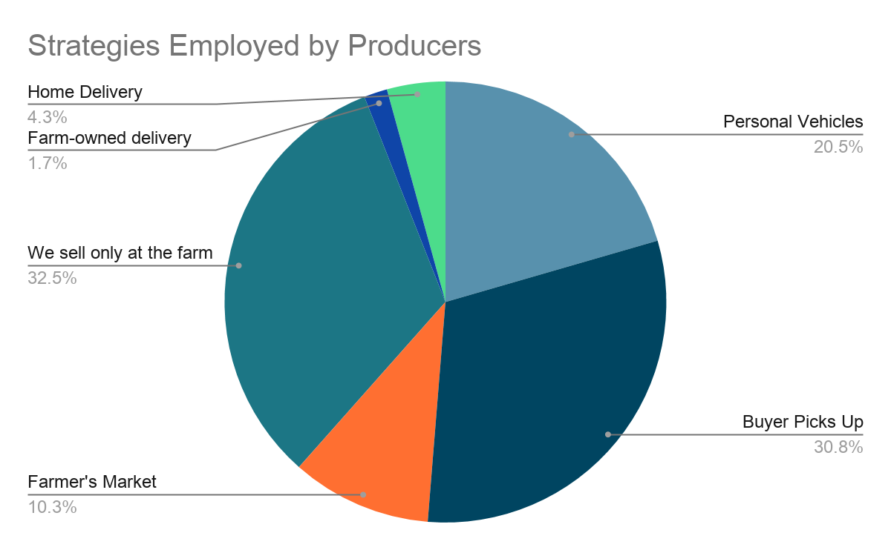

***Farmer Education***

Producers need and aspire to more knowledge and training on financing, regulations, and resources. The survey indicated a lack of awareness around resources available to them, leading; to low participation in the different grants and programs to increase fruits and vegetables and other items.

Some of the topics for farmers education include but not limited to:

* Small business administration (SBA)
* Beginning Farmer and Rancher Development Program
* Sustainable Agriculture Research and Education (SARE)
* Risk Management Education for Producers
* Farmers Market Certification (TDA)
* Agriculture Marketing Service
* Food Safety, Produce Safety Alliance
* Good Agricultural Practices Certification (GAP)

It is essential to mention that only a small number of respondents cited having any type of certification related to their field. Access to education and training could facilitate their willingness to obtain the necessary/beneficial certificates.

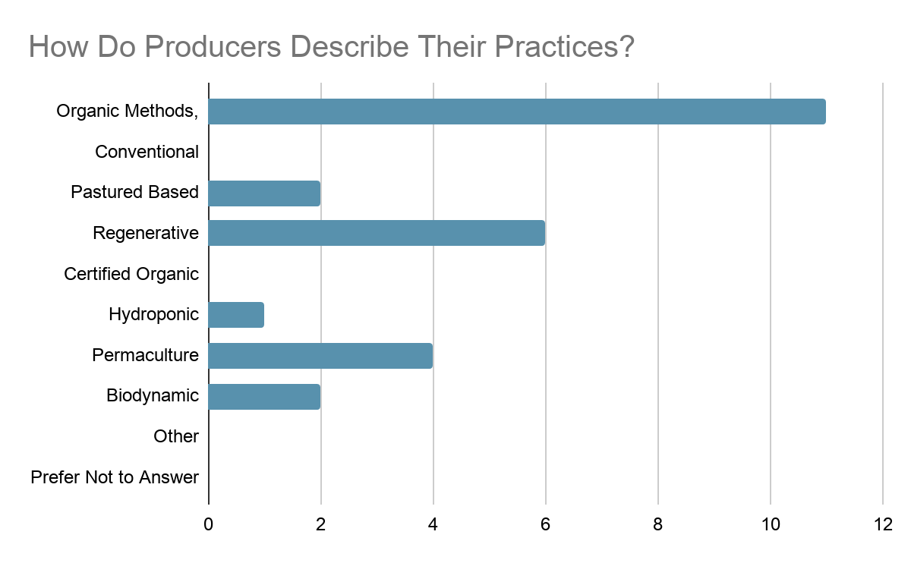

*None of the survey responses had the following certifications: Organic, Non-GMO, HACCP,

Naturally Grown, American Grass Fed Association, Animal Welfare Approved, Certified Humane, Food Justice Certified.

*Other practices include regenerative, permaculture, and biodynamic between the farmers who responded to the survey.*

Even though Farmers don’t have a certification for organic produce, they all responded to use organic methods in their practices. Something interesting would be to explore why farmers don’t obtain this certification; however, the farmers did mention that consumers sometimes don’t see the value of organic foods.

**Secondary Data Findings**

***Area Demographics***

To understand the population that comprises the Paso del Norte region, rich data on multiple demographic indicators was collected. Table 1 outlines the population, age, gender, race, and ethnicity makeup of the region as a total, the United States as a comparison, and each of the five counties in the area (Healthy Paso del Norte, 2021). Table 2 outlines the economic and education indicators for the region as a total, the United States as a comparison, and each of the five counties in the region (Healthy Paso del Norte, 2021). The year with the most recent data on each demographic can be seen next to each indicator. Through this secondary data, we achieve a snapshot of the region based on statistics used nationwide to determine population makeup.

**Table 1.** Population Makeup of the Paso del Norte Region.

| Indicator | **Paso del Norte Region** | US Averages | El Paso County | Hudspeth County | Doña Ana County | Luna County | Otero County |
| --- | --- | --- | --- | --- | --- | --- | --- |
| Population (n) (2019) | **1,153,518** | - | 839,238 | 4,886 | 218,195 | 23,709 | 67,490 |
| Population under 18 (%) (2019) | **24.14%** | 22.30% | 26.70% | 20.80% | 24.30% | 26.00% | 22.90% |
| Population over 65 (%) (2019) | **16.62%** | 16.50% | 12.50% | 15.90% | 16.20% | 21.20% | 17.30% |
| Female (%) (2018) | **49.32%** | 50.80% | 50.70% | 47.00% | 50.90% | 49.70% | 48.30% |
| Male (%) (2018) | **50.68%** | 49.20% | 49.30% | 53.00% | 49.10% | 50.30% | 51.70% |
| White (%) (2019) | **89.82%** | 73.60% | 91.80% | 90.20% | 91.80% | 92.60% | 82.70% |
| Black or African American (%) (2019) | **3.26%** | 13.40% | 4.00% | 3.80% | 2.40% | 1.90% | 4.20% |
| Native American (%) (2019) | **3.24%** | 1.30% | 1.10% | 2.00% | 2.30% | 2.50% | 8.30% |
| Asian (%) (2019) | **1.40%** | 5.90% | 1.40% | 1.60% | 1.30% | 1.10% | 1.60% |
| Native Hawaiian or Pacific Islander (%) (2019) | **0.22%** | 0.20% | 0.20% | 0.20% | 0.20% | 0.20% | 0.30% |
| Two or more races (%) (2019) | **2.12%** | 2.80% | 1.50% | 2.30% | 1.90% | 1.80% | 3.10% |
| Hispanic or Latino (%) (2019) | **67.02%** | 18.50% | 82.90% | 76.90% | 68.80% | 67.90% | 38.60% |
| White, not Hispanic or Latino (%) | **26.46%** | 60.10% | 11.60% | 17.20% | 26.70% | 28.50% | 48.30% |

**Table 2.** Economic and Educational Determinants in the Paso del Norte Region.

| Indicator | **Paso del Norte Region** | US Averages | El Paso County | Hudspeth County | Doña Ana County | Luna County | Otero County |
| --- | --- | --- | --- | --- | --- | --- | --- |
| Mean Household Income ($) (2015-2019) | **$38,174** | $62,843 | $46,871 | $31,677 | $40,973 | $29,360 | $41,988 |
| Per Capita Income ($) (2015-2019) | **$19,683** | $34,103 | $21,683 | $14,239 | $22,154 | $17,168 | $23,170 |
| People Living Below Poverty Level (%) (2015-2019) | **24.16%** | 13.40% | 20.20% | 24.40% | 26.40% | 27.70% | 22.10% |
| Population 16+ in Civilian Labor Force (%) (2015-2019) | **45.52%** | 59.6% | 55.70% | 33.60% | 52.30% | 41.50% | 44.50% |
| People 25+ with a High School Degree or Higher (%) (2015-2019) | **73.32%** | 88.00% | 78.50% | 55.50% | 79.40% | 69.80% | 83.40% |
| People 25+ with a Bachelor's Degree or Higher (%) (2015-2019) | **18.22%** | 32.10% | 23.30% | 10.70% | 27.10% | 12.50% | 17.50% |

***Food Systems Landscape***

We were able to find data on the food systems landscape from the El Paso Community Resident Survey. The survey reported that 1 in 4 El Paso residents do not have access to high-quality fresh and affordable foods. Also, 1 in 3 residents faces the challenge and risk of food insecurity (Manon, 2017). 95% of residents reported that their primary food source is a supermarket/grocery store/supercenter (Manon, 2017). With that in mind, there is a lack of food banks or food pantries and a lack of farmers’ markets that residents could benefit from. By not having comprehensive food access efforts the residents in the Paso del Norte region have poor nutrition and food insecurity. If it is available, the low-income residents cannot afford it. The way to fix this problem is to increase the community's nutrition and decrease food insecurity by expanding food availability, accessibility, and affordability.

***Agriculture Markets***

In Texas, there are 17,595,330 production acres. In New Mexico, there are 806,138 production acres. Data for each county were also collected: in Doña Ana, there are 76,223 production acres; in El Paso, there are 30,318 production acres; in Luna, there are 20,168 production acres in Otero, there are 4,492 production acres, in Hudspeth, there are 11,735 production acres.

After surveying 44000 farms about their local marketing practices, it was found that 167,009 operations used direct marketing practices to sell food in the US. 8.7 billion dollars of food was sold through direct marketing practices, including value-added products at the first point of sale. In Texas, 7% of the operations used direct food sales. Texas sits 6th in the rankings for direct to consumer sales with 4969 operations that practice this. Direct to Consumer was the most popular form of direct marketing, accounting for 69% of the total number of operations using direct marketing practices to sell food, but only accounting for 35% of total sales. The region named region 5 consists of Texas, Oklahoma, Arkansas, Louisiana, Mississippi, and Alabama. 8799 farms used Direct to Institution and intermediate strategies, which brought in 112 million dollars in revenue for the farms. Many operations sell Vegetables, Fruits and Nuts, and beef directly more than any other product.

***Local Food Systems and Infrastructure***

The local food system in the Paso Del Norte region lacks sustainability and as a result there is a shortage of healthy produce (Desert Spoon Food Hub, 2018). The region has experienced a decline in small and mid-sized farms which was also reflected in the survey responses. As a result, there are high rates of health conditions in this area such as diabetes, heart diseases, and different cares. Obesity and malnutrition are also prevalent in the region due to the shortage of healthy fresh foods. Food hubs play a huge role in this part of the country because they facilitate the needed logistics between producers and consumers. There are a number of nonprofits that help to fill in the gaps in an attempt to promote and aid in sustainability such as Desert Spoon Food Hub and La Semilla Food Center. El Paso county recently received grant funding for a county-level Healthy Financing Initiative (HFFI). HFFI supports the development of healthy food retailers in the area and improvements in infrastructure to the disadvantaged parts of the region (Vaughn, 2019).

***Regional Food Systems Trends***

The region studied includes Far West Texas and Southern New Mexico. Both states have a variety of relevant statewide networking working in food systems. New Mexico started in 2003 the New Mexico Food and Agriculture Policy Council, which works on issues around food and agriculture systems. The New Mexico Food & Agriculture Policy Council is coordinated by Farm to Table, a 501(c)(3) organization, which is its fiscal sponsor.

The Texas A&M AgriLife Extension Service is a statewide network of professionals who together provide innovative solutions at the intersection of agriculture, natural resources, youth, and health. Also, another example is the Texas Center for Local Food who aid and resources for market development to support the family farm and ranch prosperity. These are just some resources that the Region can access to complement its local resources.

**Recommendations**

The recommendations we have for Desert Spoon are from the survey participants’ responses. The first recommendation is to conduct focus groups & interviews with the producers. This will be helpful to learn more about the barriers to expanding sales and producing additional products. As previously mentioned, some of the respondents said that additional skilled labor, access to more water, improve distribution strategies, and community-supported agriculture were a few of the barriers to expanding their production. Another recommendation is to add additional farmers’ markets in areas with low access to fresh produce or grocery stores. The creation or support of an initiative to eat local could draw attention to the product grown in the area and educate the public about the importance of buying local. Surveying the crowd to learn what products they would like to purchase could also be helpful to the producers. Knowing what the consumers want more or less could help them make additional profits. Another comment that came up throughout the survey was that the producers would like to have more business skills to run their operations better. Perhaps having business management workshops that apply to the producers and their work would help them to the point where they can make profitable investments such as additional cars to transport the produce to the farmers’ markets or become organically certified. The survey was also emailed to partners in the area, such as other food hubs, distributors, and school systems, but we did not receive any responses. Reaching out to this group again would help understand other barriers to the current food system food chain.

Other recommendations from county food system assessments, the literature, and academic centers emphasize improving the current infrastructure and creating sustainable interventions to improve the food system. One suggestion from these sources is to hire a food system coordinator whose primary role would be to focus on policies, programs, and relationships between the different components of the food system (Seiber, 2020). Working with the community businesses as well as the farmers would help to identify gaps and develop ways to improve these partnerships. Another recommendation from the University of Michigan Center for Sustainable Systems is for farmers to reduce their dependence on fossil fuels. Doing so would decrease their costs, especially when oil has a sharp increase, and allow finances to be allocated in other areas of the producers’ production (Center for Sustainable Systems, 2020). A third recommendation is to provide incentives, such as tax breaks, for farmers that participate at the local farmer’s markets or provide fresh produce to local restaurants and businesses (Seiber, 2020). This would enable community partnerships and introduce healthier options into the community while reducing production costs.

**References**

Centers for Disease Control and Prevention (U.S.). (2021, January 12). *Poor Nutrition | CDC*.

<https://www.cdc.gov/chronicdisease/resources/publications/factsheets/nutrition.htm>

Center for Sustainable Systems, University of Michigan. 2020. "U.S. Food System Factsheet."

Pub. No. CSS01-06.

Cuellar, A. and M. Webber (2010) “Wasted food, wasted energy: The embedded energy in food

waste in the United States.” Environmental Science & Technology, 44(16): 6464-69.

Desert Spoon Food Hub. (2018). *About Us*. Desert Spoon Food Hub.

https://www.desertspoonfoodhub.org/about/

Farm to Table NM. (2020). *New Mexico Food & Agriculture Policy Council*. Farm to Table New Mexico. Retrieved May 1, 2021, from <https://www.farmtotablenm.org/>

Food and Agriculture Organization of the United Nations. (n.d.). *Sustainable food systems:*

*Concept and framework*. 8.

Hadjikakou, M., Ritchie, E. G., Watermeyer, K. E., & Bryan, B. A. (2019). Improving the

assessment of food system sustainability. *The Lancet Planetary Health*, *3*(2), E62–E63.

Healthy Paso del Norte. (n.d.). *Explore Data*. Healthy Paso del Norte. Retrieved May 2, 2021, from <http://www.healthypasodelnorte.org/>

National Agricultural Statistics Service. (2015). *Local food marketing practice survey*. United States Department of Agriculture. Retrieved from [Background (usda.gov)](https://www.nass.usda.gov/Publications/AgCensus/2012/Online_Resources/Local_Food/pdf/LocalFoodsBriefingPresentation_FINAL.pdf).

Manon, M., Ramos, A., Young, C., & Lang, B. (2017). *Food for Every Child: Access and Demand for Healthy Food in the Paso del Norte Region*. The Food Trust. http://thefoodtrust.org/uploads/media_items/paso-del-norte-report.original.pdf.

Regional Stakeholders Committee (2009), “*The Paso del Norte Region, US-Mexico:*

*Self-Evaluation Report*”, OECD Reviews of Higher Education in Regional and City

Development, IMHE. Retrieved May 3, 2021 from

<http://www.oecd.org/edu/imhe/regionaldevelopment>

Seiber, N., Horn, E., & Goertzen, S. (2020). Food System Assessment. Linn County.

https://www.linncounty.org/1368/Food-System-Assessment

Story, M., Hamm, M. W., & Wallinga, D. (2009). Food Systems and Public Health: Linkages to

Achieve Healthier Diets and Healthier Communities. *Journal of Hunger &*

*Environmental Nutrition*, *4*(3–4), 219–224.<https://doi.org/10.1080/19320240903351463>

Texas Local Food. (n.d.). *Food System*. Texas Local Food. Retrieved May 1, 2021, from https://texaslocalfood.org/

The County Health Rankings. (2021). *Food Environment Index*. County Health Rankings &

Roadmaps. Retrieved 4 14, 2021, from <https://www.countyhealthrankings.org/>

United States Department of Agriculture. (n.d.). *Home | Dietary Guidelines for Americans*.

Retrieved May 4, 2021, from<https://www.dietaryguidelines.gov/>

USDA National Agriculture Statistics Service, “County Summary Highlights, 2017” 2017, retrieved May 3, 2021from [st48_2_0001_0001.pdf (usda.gov)](https://www.nass.usda.gov/Publications/AgCensus/2017/Full_Report/Volume_1,_Chapter_2_County_Level/Texas/st48_2_0001_0001.pdf).

Vaughn, S. (2019). *El Paso, Texas Launches Nation’s First County-Level Healthy Food*

*Financing Initiative*. Moms Rising. https://www.momsrising.org/blog/el-paso-texas-launches-nations-first-county-level-healthy-food-financing-initiative

**Appendix**

**Appendix 1**. Producer Survey Questions and Full Results

**Q2 - In what zip code is your farm located?**

| In what zip code is your farm located? |
| --- |
| 88001 |
| 79904 |
| 79927 |
| 88007 |
| 88007 |
| 87930 |
| 88044 & 88058 |
| 87939 |
| 88007 |
| 79927 |
| 88007 |

**Q3 - How many years have you been farming?**

| # | Answer | % | Count |
| --- | --- | --- | --- |
| 1 | 0-5 | 36.36% | 4 |
| 2 | 6-10 | 54.55% | 6 |
| 3 | 11-20 | 9.09% | 1 |
| 4 | 21+ | 0.00% | 0 |
|  | Total | 100% | 11 |

**Q4 - Please select the option that best describes your land access for farming activities**

| # | Answer | % | Count |
| --- | --- | --- | --- |
| 1 | I own all of the land | 72.73% | 8 |
| 2 | I own and rent the land | 9.09% | 1 |
| 3 | I rent all of the land | 9.09% | 1 |
| 4 | Other | 9.09% | 1 |
|  | Total | 100% | 11 |

**Q5 - What volume of each of the following do you currently grow or produce on your farm? For example, volume can be estimates listed in pounds, acres, sales, cases, etc. If you do not wish to share specific volumes, please simply put an "x" next to those products produced on your farm. Check as many as apply.**

| # | Answer | % | Count |
| --- | --- | --- | --- |
| 1 | Vegetables | 25.00% | 10 |
| 2 | Protein/Meat | 2.50% | 1 |
| 3 | Fruit | 17.50% | 7 |
| 4 | Grains | 0.00% | 0 |
| 5 | Eggs | 17.50% | 7 |
| 6 | Flowers | 7.50% | 3 |
| 7 | Legumes | 5.00% | 2 |
| 8 | Value added product | 7.50% | 3 |
| 9 | Prepared foods | 2.50% | 1 |
| 10 | Dairy | 2.50% | 1 |
| 11 | Processed fruits and vegetables (frozen, chopped, etc.) | 2.50% | 1 |
| 12 | I'd prefer not to say | 0.00% | 0 |
| 13 | Other (please specify) | 10.00% | 4 |
|  | Total | 100% | 40 |

Q5 TEXT - Vegetables

| Vegetables - Text |
| --- |
| $10,000 |
| 1 acre |
| 15 lbs |
| 3000 pounds |
| 500 lbs |
| 2 acres |
| Don’t know |
| x |

Q5 TEXT - Fruit

| Fruit - Text |
| --- |
| 1/3 acre about 700 lbs |
| 600 lbs |
| 1000 trees apples, peaches, plums, apricots, pomegranates,pears |
| Don’t know |

Q5 TEXT - Eggs

| Eggs - Text |
| --- |
| $3000 |
| 400 eggs |
| 6 dozens /week |
| 125 chickens and 40 ducks |
| Don’t know |

Q5_6_TEXT - Flowers

| Flowers - Text |
| --- |
| 1/4 acre |

Q5_7_TEXT - Legumes

| Legumes - Text |
| --- |
| 2000 pounds |

Q5_8_TEXT - Value added product

| Value added product - Text |
| --- |
| Jams, fruit juice, pasta |
| x |

Q5_9_TEXT - Prepared foods

| Prepared foods - Text |
| --- |
| Bread |

Q5 TEXT - Processed fruits and vegetables (frozen, chopped, etc.)

| Processed fruits and vegetables (frozen, chopped, etc.) - Text |
| --- |
| x |

Q5_13_TEXT - Other (please specify)

| Other (please specify) - Text |
| --- |
| Pecans 500 lbs |
| Pecans 500 pounds |
| Pecans |

**Q6 - Approximately how many acres of fresh fruits and vegetables do you farm?**

| # | Answer | % | Count |
| --- | --- | --- | --- |
| 1 | <4 | 72.73% | 8 |
| 2 | 5-9 | 9.09% | 1 |
| 3 | 10-24 | 18.18% | 2 |
|  | Total | 100% | 11 |

**Q7 - Would you be interested in increasing production of fruits and vegetables if there's a market for the product?**

| # | Answer | % | Count |
| --- | --- | --- | --- |
| 1 | Yes | 72.73% | 8 |
| 2 | Unsure | 0.00% | 0 |
| 3 | No | 9.09% | 1 |
| 4 | Yes, but I don't have additional acreage | 18.18% | 2 |
|  | Total | 100% | 11 |

**Q8 - How many plant-able acres do you have access to in addition to what's currently in use?**

| # | Answer | % | Count |
| --- | --- | --- | --- |
| 1 | 0-4 | 72.73% | 8 |
| 2 | 5-9 | 18.18% | 2 |
| 3 | 10-24 | 0.00% | 0 |
| 4 | 25-49 | 0.00% | 0 |
| 5 | 50-99 | 0.00% | 0 |
| 6 | 100+ | 0.00% | 0 |
| 7 | Prefer not to say | 9.09% | 1 |
|  | Total | 100% | 11 |

**Q9 - If you are seeking (or would seek) additional acreage for the production of fresh fruits, vegetables or livestock, how many acres would you need?**

| # | Answer | % | Count |
| --- | --- | --- | --- |
| 1 | 0-4 | 72.73% | 8 |
| 2 | 5-9 | 9.09% | 1 |
| 3 | 10-24 | 0.00% | 0 |
| 4 | 25-49 | 0.00% | 0 |
| 5 | 50-99 | 0.00% | 0 |
| 6 | Prefer not to say | 18.18% | 2 |
|  | Total | 100% | 11 |

**Q10 - If you produce goods other than fresh fruits and vegetables, please indicate your volumes and acres used here. For example, 50 head of cattle on 100 acres of soy, etc.**

| If you produce goods other than fresh fruits and vegetables, please indicate your volumes and acres used here. For example, 50 head of cattle on 100 acres of soy, etc. |
| --- |
| N/A |
| N/A |
| 5 sheep in 1/3 acre, 3 hens free range over 1 acre |
| 4 acres pecans |
| 1 acre pecans |
| Microgreens 1200 sq ft |

**Q11 - Out of the fruit/vegetable category, which is your focus? Check all that apply.**

| # | Answer | % | Count |
| --- | --- | --- | --- |
| 2 | Apples | 2.91% | 3 |
| 3 | Wheat | 0.00% | 0 |
| 4 | Broccoli | 0.97% | 1 |
| 5 | Corn | 4.85% | 5 |
| 6 | Cucumbers | 4.85% | 5 |
| 7 | Eggplant | 2.91% | 3 |
| 8 | Garlic | 5.83% | 6 |
| 9 | Green beans | 3.88% | 4 |
| 10 | Hard squash | 2.91% | 3 |
| 11 | Herbs | 7.77% | 8 |
| 12 | Leafy greens | 9.71% | 10 |
| 13 | Lettuce | 5.83% | 6 |
| 14 | Melons | 5.83% | 6 |
| 15 | Microgreens | 2.91% | 3 |
| 16 | Mushrooms | 0.00% | 0 |
| 17 | Onions | 4.85% | 5 |
| 18 | Pears | 3.88% | 4 |
| 19 | Pecans | 3.88% | 4 |
| 20 | Plums | 1.94% | 2 |
| 21 | Pomegranates | 4.85% | 5 |
| 22 | Root vegetables | 5.83% | 6 |
| 23 | Soft squash | 3.88% | 4 |
| 24 | Tomatoes | 7.77% | 8 |
| 25 | Other | 1.94% | 2 |
|  | Total | 100% | 103 |

Q11 TEXT - Other

| Other - Text |
| --- |
| Quince |
| Peaches |

**Q26 - If your pricing requirements were met, what type and volume of new or additional products would you be interested in selling? Indicate volume next to the appropriate category, for example 100 dozen eggs or 200 pounds of frozen berries**

| # | Answer | % | Count |
| --- | --- | --- | --- |
| 1 | Vegetable | 26.09% | 6 |
| 2 | Protein/Meat | 0.00% | 0 |
| 3 | Value Added Products | 13.04% | 3 |
| 4 | Eggs | 17.39% | 4 |
| 5 | Flowers | 4.35% | 1 |
| 6 | Fruit | 26.09% | 6 |
| 7 | Grains | 0.00% | 0 |
| 8 | Prepared Foods | 4.35% | 1 |
| 9 | Processed | 8.70% | 2 |
| 10 | Legumes | 0.00% | 0 |
| 11 | Dairy | 0.00% | 0 |
|  | Total | 100% | 23 |

Q26 TEXT - Vegetable

| Vegetable - Text |
| --- |
| 5000 pounds |
| 1000 lb |
| 150 lbs |

Q26 TEXT - Value Added Products

| Value Added Products - Text |
| --- |
| Not sure how much yet |

Q26_4_TEXT - Eggs

| Eggs - Text |
| --- |
| 260 dozen eggs |

Q26_6_TEXT - Fruit

| Fruit - Text |
| --- |
| 100 lbs |
| 150 lbs |

Q26_9_TEXT - Processed

| Processed - Text |
| --- |
| x |

**Q12 - What are the barriers preventing you from expanding into producing new or additional products from the items listed above?**

| What are the barriers preventing you from expanding into producing new or additional products from the items listed above? |
| --- |
| We are just starting out. We have no idea what regulations / limitations exist with regards to selling what we grow and produce in our farm. We also don’t know how to access the market. Who do we sell to? What do we do with our product after we harvest? Do we need to prepare our products a certain way in order to get it to market? What about product labeling? What is required? How many labor intensive hours does all that require and will the profit outweighed by the labor costs? We need advice. |
| Short of labor. |
| Our main barrier is finding experienced/skilled help |
| Labor, land, capital for supplies |
| Irrigation water |
| Help |
| Commercial Kitchen and Co Packing |
| Availability of labor |
| Acreage, equipment, water rights |
| Acreage |
| Accessible water. In the process of getting water out to fields. The finances and man power to build a greenhouse. |

**Q13 - How would you describe the market for locally grown and raised products? Please rate the following statements from agree to disagree**

| # | Question | Strongly Agree |  | Somewhat agree |  | Neither agree nor disagree |  | Somewhat disagree |  | Strongly disagree |  | Total |
| --- | --- | --- | --- | --- | --- | --- | --- | --- | --- | --- | --- | --- |
| 1 | Shoppers seek local products | 45.45% | 5 | 45.45% | 5 | 9.09% | 1 | 0.00% | 0 | 0.00% | 0 | 11 |
| 2 | Shoppers pay more for local products | 50.00% | 5 | 50.00% | 5 | 0.00% | 0 | 0.00% | 0 | 0.00% | 0 | 10 |
| 3 | Shoppers need education about local products | 77.78% | 7 | 11.11% | 1 | 11.11% | 1 | 0.00% | 0 | 0.00% | 0 | 9 |
| 4 | Institutional buyers seek local products | 9.09% | 1 | 72.73% | 8 | 18.18% | 2 | 0.00% | 0 | 0.00% | 0 | 11 |
| 5 | Institutional buyers pay more for local products | 9.09% | 1 | 54.55% | 6 | 18.18% | 2 | 18.18% | 2 | 0.00% | 0 | 11 |
| 6 | Farmers sell large quantities of local products | 9.09% | 1 | 9.09% | 1 | 45.45% | 5 | 27.27% | 3 | 9.09% | 1 | 11 |
| 7 | Farmers sell diverse products | 27.27% | 3 | 9.09% | 1 | 36.36% | 4 | 18.18% | 2 | 9.09% | 1 | 11 |
| 8 | Farmers sell diverse products | 27.27% | 3 | 9.09% | 1 | 36.36% | 4 | 18.18% | 2 | 9.09% | 1 | 11 |
| 9 | Farmers have diverse costumers | 18.18% | 2 | 45.45% | 5 | 27.27% | 3 | 0.00% | 0 | 9.09% | 1 | 11 |
| 10 | Local product demand > supply | 18.18% | 2 | 45.45% | 5 | 27.27% | 3 | 0.00% | 0 | 9.09% | 1 | 11 |

**Q14 - Which of the following distribution strategies do you employ on your farm? Select all that apply**

| # | Answer | % | Count |
| --- | --- | --- | --- |
| 1 | Personal vehicles (car, van, pick-up truck) | 28.13% | 9 |
| 2 | Buyer picks up | 18.75% | 6 |
| 3 | Farmer's market | 21.88% | 7 |
| 4 | Refrigerated vehicle | 6.25% | 2 |
| 5 | We sell only at the farm | 3.13% | 1 |
| 6 | Farm-owned delivery vehicles | 6.25% | 2 |
| 7 | Home delivery | 15.63% | 5 |
| 8 | Not applicable | 0.00% | 0 |
|  | Total | 100% | 32 |

**Q15 - How would you describe your production practices? Select all that apply**

| # | Answer | % | Count |
| --- | --- | --- | --- |
| 1 | Organic methods, not certified | 42.31% | 11 |
| 2 | Conventional | 0.00% | 0 |
| 3 | Pastured based | 7.69% | 2 |
| 4 | Regenerative agriculture | 23.08% | 6 |
| 5 | Certified organic | 0.00% | 0 |
| 6 | Other | 0.00% | 0 |
| 7 | Hydroponic | 3.85% | 1 |
| 8 | Permaculture | 15.38% | 4 |
| 9 | Biodynamic | 7.69% | 2 |
| 10 | Prefer not to answer | 0.00% | 0 |
|  | Total | 100% | 26 |

**Q16 - Do you have any of the following certifications? Select all that apply**

| # | Answer | % | Count |
| --- | --- | --- | --- |
| 1 | GAP | 16.67% | 2 |
| 2 | Organic | 0.00% | 0 |
| 3 | Non-GMO | 0.00% | 0 |
| 4 | HACCP (Hazard Analysis and Critical Control Points) | 0.00% | 0 |
| 5 | Naturally Grown | 0.00% | 0 |
| 6 | American Grass Fed Association | 0.00% | 0 |
| 7 | Animal Welfare Approved | 0.00% | 0 |
| 8 | Certified Humane | 0.00% | 0 |
| 9 | Food Justice Certified | 0.00% | 0 |
| 10 | New Mexico Tier/Tier 11 | 8.33% | 1 |
| 11 | Produce Safety Alliance | 16.67% | 2 |
| 12 | Other (please specify) | 0.00% | 0 |
| 13 | I do not have any certifications | 58.33% | 7 |
|  | Total | 100% | 12 |

**Q17 - Approximately what percentage of your 2020 gross income from farming operations was through each of the following channels? Please enter percentages as whole numbers (e.g. enter 20 to denote 20%)**

| # | Field | Minimum | Maximum | Mean | Std Deviation | Variance | Count |
| --- | --- | --- | --- | --- | --- | --- | --- |
| 1 | Wholesale/food hub | 1.00 | 80.00 | 47.63 | 28.41 | 806.98 | 8 |
| 2 | Community Supported Agriculture/CSA or pre-sold boxes | 0.00 | 25.00 | 10.50 | 9.95 | 98.92 | 6 |
| 3 | On-farm sales/retail | 0.00 | 75.00 | 32.50 | 24.11 | 581.25 | 6 |
| 4 | Farmers Markets | 1.00 | 52.00 | 19.50 | 17.08 | 291.58 | 6 |
| 5 | Restaurants | 0.00 | 30.00 | 9.20 | 11.86 | 140.56 | 5 |
| 6 | Other (please specify) | 0.00 | 70.00 | 31.67 | 28.96 | 838.89 | 3 |

Q17 Other (please specify)

| Other (please specify) - Text |
| --- |
| Stores & direct customer sales |
| Etsy |
| Very little b/c of covid-19 |
| We are new. Have not started selling |

**Q18 - In which of the following channels, if any would you like to expand your sales? Select all that apply**

| # | Answer | % | Count |
| --- | --- | --- | --- |
| 1 | Wholesale, institutional sales, food hub | 15.63% | 5 |
| 2 | On-farm sales/retail | 12.50% | 4 |
| 3 | Restaurants | 15.63% | 5 |
| 4 | Community Supported Agriculture/CSA or pre-sold boxes | 25.00% | 8 |
| 5 | Farmers Markets | 21.88% | 7 |
| 6 | Produce auctions | 0.00% | 0 |
| 7 | Universities | 9.38% | 3 |
| 8 | None of the above | 0.00% | 0 |
|  | Total | 100% | 32 |

**Q19 - If you are considering wholesale, please indicate the top three possible barriers preventing you from entering or increasing participation in these non-direct to consumer channels.**

| # | Answer | % | Count |
| --- | --- | --- | --- |
| 1 | Pricing- receiving too low a price | 20.83% | 5 |
| 2 | Volume- having enough product to fill their orders | 20.83% | 5 |
| 3 | Distribution/transportation- complex logistics selling to wholesale customers | 8.33% | 2 |
| 4 | Accessibility- unsure how to meet buyers | 4.17% | 1 |
| 5 | Certifications | 16.67% | 4 |
| 6 | Other | 0.00% | 0 |
| 7 | Requirements- unable or unsure about meeting standars for quality, handling, packing, service | 4.17% | 1 |
| 8 | Capital- ability to cover the upfront expense of land, labor, or raw materials | 12.50% | 3 |
| 9 | No applicaple | 12.50% | 3 |
|  | Total | 100% | 24 |

**Q20 - What ideas do you have that would reduce the barriers to selling locally grown and raised products?**

| What ideas do you have that would reduce the barriers to selling locally grown and raised products? |
| --- |
| Not sure |
| Community education |
| People expect lower prices with local products but pay top prices at specialty shops. |
| Better distribution |
| Education. Zoom workshops. |
| Changing public perception of value |

**Q21 - Do you currently have the following infrastructure? Select all that apply**

| # | Answer | % | Count |
| --- | --- | --- | --- |
| 1 | Cooler | 20.00% | 4 |
| 2 | Greenhouse | 15.00% | 3 |
| 3 | Packing shed | 5.00% | 1 |
| 4 | Washing station | 35.00% | 7 |
| 5 | Dry storage | 15.00% | 3 |
| 6 | High tunnel | 0.00% | 0 |
| 7 | Wash line | 0.00% | 0 |
| 8 | Packing line | 0.00% | 0 |
| 9 | Certified kitchen | 5.00% | 1 |
| 10 | Refrigerated truck | 0.00% | 0 |
| 11 | Chopping equipment | 5.00% | 1 |
| 12 | Meat processing equipment | 0.00% | 0 |
| 13 | Slaughter facilities | 0.00% | 0 |
| 14 | Other | 0.00% | 0 |
|  | Total | 100% | 20 |

**Q22 - Do you have excess capacity in any of the infrastructure you described above (delivery vehicle, cooler, processing equipment) that you might be willing to make available to neighboring growers or a food hub for a fee?**

| # | Field | Minimum | Maximum | Mean | Std Deviation | Variance | Count |
| --- | --- | --- | --- | --- | --- | --- | --- |
| 1 | Do you have excess capacity in any of the infrastructure you described above (delivery vehicle, cooler, processing equipment) that you might be willing to make available to neighboring growers or a food hub for a fee? | 2.00 | 2.00 | 2.00 | 0.00 | 0.00 | 11 |

| # | Answer | % | Count |
| --- | --- | --- | --- |
| 1 | yes | 0.00% | 0 |
| 2 | No | 100.00% | 11 |
|  | Total | 100% | 11 |

**Q23 - If you answered yes above, please describe what infrastructure you could make available.**

| If you answered yes above, please describe what infrastructure you could make available. |
| --- |
| N/A |
| N/A |
| N/A |

**Q24 - Please indicate which, if any, of the following are barriers preventing you from reaching your farm production and business goals. Select all that apply.**

| # | Answer | % | Count |
| --- | --- | --- | --- |
| 1 | Lack of costumer knowledge on the value of buying local | 5.88% | 3 |
| 2 | Risk | 1.96% | 1 |
| 3 | Buyers | 0.00% | 0 |
| 4 | Grants | 3.92% | 2 |
| 5 | Labor availability | 13.73% | 7 |
| 6 | Pricing | 5.88% | 3 |
| 7 | Land cost | 5.88% | 3 |
| 8 | Weather (extreme) | 7.84% | 4 |
| 9 | Delivery | 1.96% | 1 |
| 10 | Equipment | 3.92% | 2 |
| 11 | Meat processing | 3.92% | 2 |
| 12 | Processing | 0.00% | 0 |
| 13 | Weather (seasonal changes) | 3.92% | 2 |
| 14 | Capital | 7.84% | 4 |
| 15 | Land availability | 5.88% | 3 |
| 16 | Production planning | 1.96% | 1 |
| 17 | Business management skill | 5.88% | 3 |
| 18 | Food safety | 1.96% | 1 |
| 19 | GAP Certification | 3.92% | 2 |
| 20 | Post- harvest equipment | 1.96% | 1 |
| 21 | Recordkeeping | 1.96% | 1 |
| 22 | Financial Management | 1.96% | 1 |
| 23 | Tools | 1.96% | 1 |
| 24 | Post-harvest knowledge | 1.96% | 1 |
| 25 | Marketing | 3.92% | 2 |
| 26 | Other | 0.00% | 0 |
|  | Total | 100% | 51 |

**25 - Can we contact you and ask additional questions in a one-on-one interview? If yes, can you provide your best contact number?**

**Appendix 2.** Partner Survey Questions.

**1 - Choose the option below that best describes your operation**

| # | Answer | % | Count |
| --- | --- | --- | --- |
| 1 | Food Hub | 0.00% | 0 |
| 2 | Grocery Store | 0.00% | 0 |
| 3 | Restaurant | 0.00% | 0 |
|  | Total |  | 0 |

**2 - In what zip code is your business located?**

**3 - Please indicate which of the following, if any, you are willing to pay a premium**

| # | Answer | % | Count |
| --- | --- | --- | --- |
| 1 | Locally grown | 0.00% | 0 |
| 2 | GAP (Good Agricultural Practices) | 0.00% | 0 |
| 3 | Organic | 0.00% | 0 |
| 4 | Non-GMO Verified | 0.00% | 0 |
| 5 | HACCP (Hazard Analysis and Critical Control Points) | 0.00% | 0 |
| 6 | Naturally Grown | 0.00% | 0 |
| 7 | American Grass Fed Association | 0.00% | 0 |
| 8 | Animal Welfare Approved | 0.00% | 0 |
| 9 | Certified Humane | 0.00% | 0 |
| 10 | Food Justice Certified | 0.00% | 0 |
| 12 | Other (please specify) | 0.00% | 0 |
|  | Total |  | 0 |

**4 - How does your organization define"local" when referring to locally grown or produced food products?**

| # | Answer | % | Count |
| --- | --- | --- | --- |
| 1 | We do not specifically define local | 0.00% | 0 |
| 2 | Grown in Texas/New Mexico | 0.00% | 0 |
| 3 | Grown within a radius between 0-120 miles | 0.00% | 0 |
| 4 | Grown within a radius between 0-60 miles | 0.00% | 0 |
| 5 | Grown within a radius between 0-200 miles | 0.00% | 0 |
| 6 | Grown in Texas, New Mexico, or adjacent states | 0.00% | 0 |
|  | Total |  | 0 |

**5 - What percentage of your total annual food budget is spent on locally sourced products (include ALL categories- produce, protein, value-added, etc.)**

| # | Answer | % | Count |
| --- | --- | --- | --- |
| 1 | 0-5% | 0.00% | 0 |
| 2 | 6-10% | 0.00% | 0 |
| 3 | 11-20% | 0.00% | 0 |
| 4 | 21-30% | 0.00% | 0 |
| 5 | 31-40% | 0.00% | 0 |
| 6 | 41+% | 0.00% | 0 |
| 7 | Prefer not to answer | 0.00% | 0 |
|  | Total |  | 0 |

**6 - What percentage of your local purchases, please indicate the percentage breakdown from each of the following categories. For example, if you spend $100 total on local food, what percentage of that is spent on vegetables? Please enter the percentage as whole numbers (e.g. enter 20 to denote 20%)**

| # | Field | Minimum | Maximum | Mean | Std Deviation | Variance | Count |
| --- | --- | --- | --- | --- | --- | --- | --- |
| 1 | Vegetables | 0.00 | 0.00 | 0.00 | 0.00 | 0.00 | 0 |
| 2 | Legumes | 0.00 | 0.00 | 0.00 | 0.00 | 0.00 | 0 |
| 3 | Value added products (i.e. salsa, jam, jerky) | 0.00 | 0.00 | 0.00 | 0.00 | 0.00 | 0 |
| 4 | Processed fruits and vegetables (frozen, chopped, etc) | 0.00 | 0.00 | 0.00 | 0.00 | 0.00 | 0 |
| 5 | Protein/meat | 0.00 | 0.00 | 0.00 | 0.00 | 0.00 | 0 |
| 6 | Dairy | 0.00 | 0.00 | 0.00 | 0.00 | 0.00 | 0 |
| 7 | Fruit | 0.00 | 0.00 | 0.00 | 0.00 | 0.00 | 0 |
| 8 | Eggs | 0.00 | 0.00 | 0.00 | 0.00 | 0.00 | 0 |
| 9 | Prepared foods (i.e. pastas, tamales, etc.) | 0.00 | 0.00 | 0.00 | 0.00 | 0.00 | 0 |
| 10 | Flowers | 0.00 | 0.00 | 0.00 | 0.00 | 0.00 | 0 |
| 11 | Other (please specify) | 0.00 | 0.00 | 0.00 | 0.00 | 0.00 | 0 |

**7 - Who are your primary suppliers of local farm produce?**

| # | Answer | % | Count |
| --- | --- | --- | --- |
| 1 | Farmers | 0.00% | 0 |
| 2 | Food Hubs | 0.00% | 0 |
| 3 | Distributors | 0.00% | 0 |
|  | Total |  | 0 |

**8 - What are the top three challenges you face when purchasing local farm products?**

| # | Answer | % | Count |
| --- | --- | --- | --- |
| 1 | Pricing- product is too expensive | 0.00% | 0 |
| 2 | Supply- not able to consistently provide product | 0.00% | 0 |
| 3 | Volume- unable to fill the quantity needed | 0.00% | 0 |
| 4 | Timing- seasonality of produce does not align with consumer demand | 0.00% | 0 |
| 5 | Effort- too much effort required on my part to find and source local | 0.00% | 0 |
| 6 | Diversity of product- not enough selection | 0.00% | 0 |
| 7 | Quality- product does not meet grading standards | 0.00% | 0 |
| 8 | Professional skills of suppliers- unprofessional or poor communication | 0.00% | 0 |
| 9 | Certifications | 0.00% | 0 |
| 10 | Other (please specify) | 0.00% | 0 |
|  | Total |  | 0 |

**9 - What do you require of suppliers in terms of food safety?**

| # | Answer | % | Count |
| --- | --- | --- | --- |
| 1 | Food safety certification (i.e Good Agricultural Practices/GAP) | 0.00% | 0 |
| 2 | None | 0.00% | 0 |
| 3 | Other | 0.00% | 0 |
|  | Total |  | 0 |

**10 - How much more would you purchase of the following locally sourced products if it were available and the necessary requirements were met? Indicate volume next to the appropriate category, for example 100 dozen eggs or 200 pounds of frozen berries, etc.)**

| # | Answer | % | Count |
| --- | --- | --- | --- |
| 1 | Fruit | 0.00% | 0 |
| 2 | Vegetables | 0.00% | 0 |
| 3 | Protein/Meat | 0.00% | 0 |
| 4 | Eggs | 0.00% | 0 |
| 5 | Processed fruits and vegetables | 0.00% | 0 |
| 6 | Dairy | 0.00% | 0 |
| 7 | Grains | 0.00% | 0 |
| 8 | Legumes | 0.00% | 0 |
| 9 | Prepared foods | 0.00% | 0 |
| 10 | Value added products | 0.00% | 0 |
|  | Total |  | 0 |

**11 - Which of the following describes your standard price strategy with respect to the local farm products?**

| # | Answer | % | Count |
| --- | --- | --- | --- |
| 1 | Generally lower than non-local | 0.00% | 0 |
| 2 | Generally a small premium compared to non-local | 0.00% | 0 |
| 3 | Generally the same as non-local | 0.00% | 0 |
| 4 | Other | 0.00% | 0 |
|  | Total |  | 0 |

**12 - What are the top farm products you are interested in getting from local sources? Select all that you are interested in**

| # | Answer | % | Count |
| --- | --- | --- | --- |
| 1 | Fruit | 0.00% | 0 |
| 2 | Vegetables | 0.00% | 0 |
| 3 | Protein/Meat | 0.00% | 0 |
| 4 | Dairy | 0.00% | 0 |
| 5 | Eggs | 0.00% | 0 |
| 6 | Processed fruit and vegetables (frozen, chopped, etc.) | 0.00% | 0 |
| 7 | Legumes | 0.00% | 0 |
| 8 | Grains | 0.00% | 0 |
| 9 | Prepared foods | 0.00% | 0 |
| 10 | Flowers | 0.00% | 0 |
| 11 | Value added products | 0.00% | 0 |
| 12 | Other | 0.00% | 0 |
|  | Total |  | 0 |

**13 - How would you describe the market for locally grown and raised products? Please rate the following statements from agree, neutral, disagree.**

| # | Question | Strongly agree |  | Agree |  | Somewhat agree |  | Neither agree nor disagree |  | Somewhat disagree |  | Disagree |  | Strongly disagree |  | Total |
| --- | --- | --- | --- | --- | --- | --- | --- | --- | --- | --- | --- | --- | --- | --- | --- | --- |
| 1 | Shoppers and diners seek out local products | 0.00% | 0 | 0.00% | 0 | 0.00% | 0 | 0.00% | 0 | 0.00% | 0 | 0.00% | 0 | 0.00% | 0 | 0 |
| 2 | Shoppers and diners are willing to pay more for local products | 0.00% | 0 | 0.00% | 0 | 0.00% | 0 | 0.00% | 0 | 0.00% | 0 | 0.00% | 0 | 0.00% | 0 | 0 |
| 3 | Shoppers and diners in the Paso del Norte region need education on the value of local food | 0.00% | 0 | 0.00% | 0 | 0.00% | 0 | 0.00% | 0 | 0.00% | 0 | 0.00% | 0 | 0.00% | 0 | 0 |
| 4 | Institutional buyers seek out local products | 0.00% | 0 | 0.00% | 0 | 0.00% | 0 | 0.00% | 0 | 0.00% | 0 | 0.00% | 0 | 0.00% | 0 | 0 |
| 5 | Farmers have the opportunity to sell large quantities of local products | 0.00% | 0 | 0.00% | 0 | 0.00% | 0 | 0.00% | 0 | 0.00% | 0 | 0.00% | 0 | 0.00% | 0 | 0 |
| 6 | Farmers have a diverse choice in customers to sell to | 0.00% | 0 | 0.00% | 0 | 0.00% | 0 | 0.00% | 0 | 0.00% | 0 | 0.00% | 0 | 0.00% | 0 | 0 |
| 7 | Demand for local product exceeds supply | 0.00% | 0 | 0.00% | 0 | 0.00% | 0 | 0.00% | 0 | 0.00% | 0 | 0.00% | 0 | 0.00% | 0 | 0 |

**14 - What are some of the Paso del Norte food system challenges you've experienced? Any that we missed in this survey?**

**15 - What are some of the Paso del Norte Food System opportunities you see?**

**16 - Can we contact you and ask additional questions in a one-on-one interview? If yes, can you provide your best contact number?**